How to customize a module

Contents

Overview 2

S3 file structure reminder 3

Editing a module 4

Editing module groups 10

Editing mini-lesson descriptions 11

Adding and removing modules 13

Removing a module 13

Adding a module 13

Adding and removing module groups 15

Removing a group 15

Adding a group 16

Adding and removing mini-lessons 16

Removing a mini-lesson 16

Adding a mini-lesson 17

# Overview

A JUICE module is the basic unit of content in JUICE. Most modules cover a competency such as “Writing a five-paragraph essay” or “Solving problems involving units of measurement.” Each module consists of a set of modulettes (mini-lessons) that present the skills required to master the module’s competency.

Students access JUICE modules by clicking a link on the JUICE dashboard. They can also launch directly to a module from an LMS using the appropriate target in an LTI launch.  
  
When students access a JUICE module, they start on a “module page” that introduces the module and provides information about and links to the mini-lessons that the module includes. Module pages may also include a low stakes diagnostic game called the “Challenge Wheel.”

All module pages look something like this:

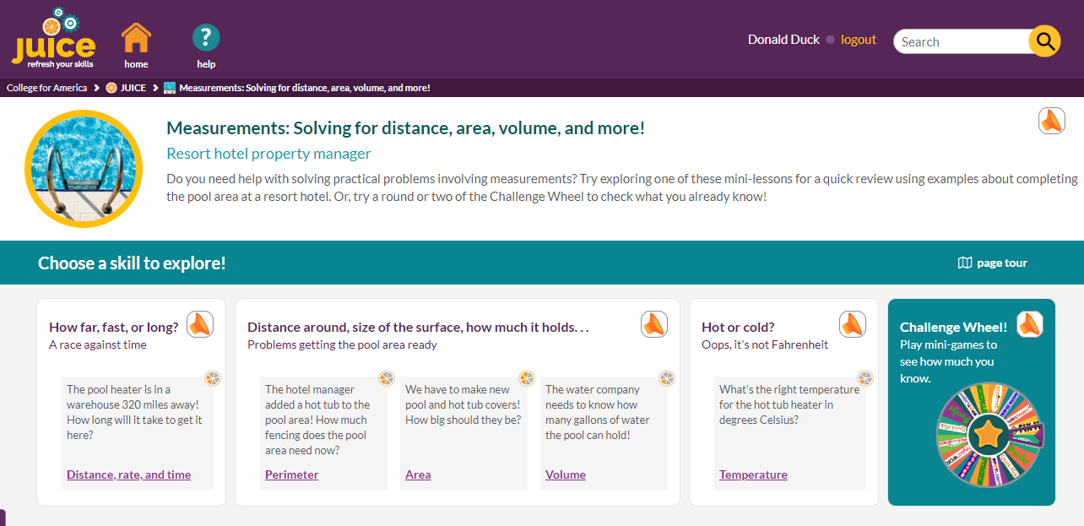

The top of the page displays the module’s title, subtitle, and description. The main part of the page includes one or more boxes called “groups” that contain the mini-lessons.

The information displayed on the module page is in a file in the module’s directory called **module.txt**.

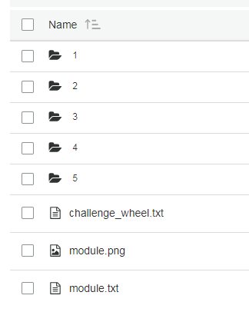

You may update the module’s text and mini-lesson information by editing the **module.txt** file.

IMPORTANT! Content-related changes made in **module.txt** will only be reflected on the module page.   
  
To make content changes to the JUICE dashboard, you must edit the **modules.txt** file. To make content changes to a mini-lesson (modulette), you must edit the appropriate **modulette.txt** file.

For example, if you change the name of a module by editing that module’s **module.txt** file, the new name will appear on the corresponding module page, but will not appear on the JUICE dashboard unless you also change the **modules.txt** files.

## S3 file structure reminder

Module and modulette ids correspond to directory names in S3. For example,

* The files for module QS1 are found in the S3 directory QS1.
* The files for modulette QS1.1 re found in the S3 directory QS1/1.

Files for alternate (custom) programs are found in the specific alternate program’s directory, which is located in /programs.

Note that S3 uses the forward slash (/) for path names rather than the DOS backslash (\)

# Editing a module

To edit an existing module:

1. Go to S3 and open the folder of the module you want to edit. Folders are identified by their module ID.

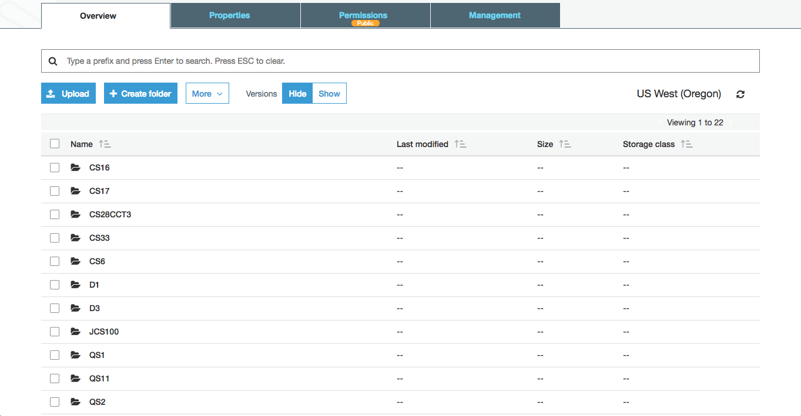

1. Make a note of the module IDs that are already in your program. Do not edit a module to use an ID that is already in use.
2. Find the **module.txt** file in the module’s folder. Select the checkbox next to the file, then click the download button. Open the downloaded .txt file with Brackets or other structured editing program.

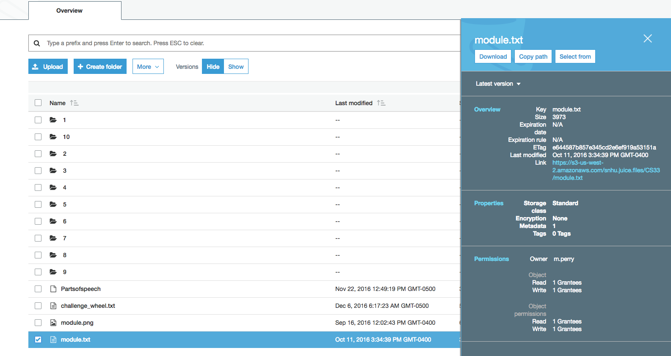

1. The opened file will look something like this. To change the information displayed on the module page, edit the values associated with the appropriate json parameters. See the table below for details:

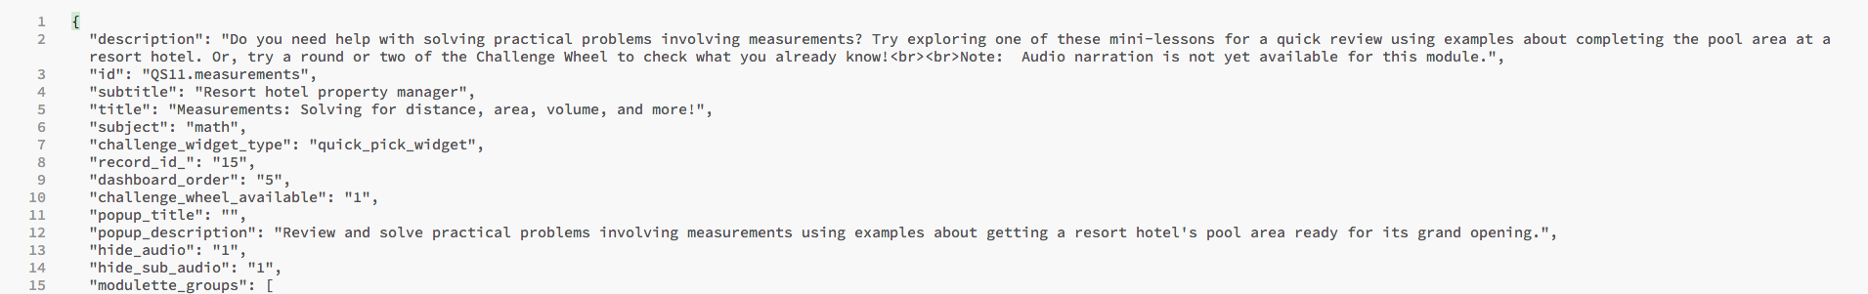

| **json parameter** | **Notes** |
| --- | --- |
| description | This is the text that appears at the top of the module page, under the module title and subtitle: |
| id | “id” is a combination of a module’s unique identifier/S3 directory name and a brief description.  For example, if the id is **QS11.measurements**, QS11 is the module’s unique identifier and S3 directory name, and “measurements” is the description of what the module covers.  The first part of the module ID must match its directory name in S3, or the module will not be found by the site.  It is recommended as a best practice to not change a module ID.  If you change this value, you must also change it in **modules.txt**. |
| subtitle | This text appears in light blue on the module page. It usually describes the context. This is optional. |
| title | This text appears in teal on the module page. It is usually a “friendly skill name.” Students should be able to recognize what the module is about when they see this name.    This name also appears on the dashboard and in the search tables. If you change this value, you must also change it in **modules.txt** and in the search tables in Mongo DB. See the document *Using tags to improve JUICE Search* for more information about updating Search. |
| subject | This controls the color of the broad bands in the UI on the module page.  The supported choices are “math” or “writing.” JUICE currently uses “writing” for anything non-quantitative. Writing is green, and math is blue |
| challenge_widget_type | If the module includes a challenge wheel game, this parameter defines which game widget type will be used. The format for the challenge widget type is “gamename_widget”.  Not all game widgets can be used for challenge wheel games. The available widgets are:  balancer_widget finders_keepers_widget fridge_magnets_widget highlighter_widget (this is the Spotlight game) pick_and_stack_widget quick_pick_widget |
| record_id | This is the database record ID from JUICE’s original content management system. It is for information only and not used in the site. |
| dashboard_order | The dashboard_order field in **module.txt** is informational, and editing it will not impact the module order on the dashboard.  To change the order in which modules appear on the dashboard, edit the module dashboard_order values in the file **modules.txt**. |
| challenge_wheel_available | This setting tells the module page to display the “group” the holds the challenge wheel game.  “challenge_wheel_available”: “0”, means that challenge wheel game will not appear.  “challenge_wheel_available”: “1”, means thes challenge wheel game will appear. |
| popup_title | When users launch a JUICE module page, they see a modal pop-up welcoming them to JUICE. The title is the text in green.  If nothing is defined for the popup_title, this will display the module title: |
| popup_description | The pop-up description is the text underneath the pop-up title. If nothing is defined, it will display the module description. |
| hide_audio | Hides the audio icon from the introductory section at the top of the module page:    “hide_audio”: “1” will hide the audio icon. “hide_audio”: “0” will display it.  See the documentation *Adding and customizing narration* for more information. |
| hide_sub_audio | Hides the audio icon from the groups on the module page.    “hide_audio”: “1” will hide the audio icon in all the groups. “hide_audio”: “0” will display it.  See the documentation *Adding and customizing narration* for more information. |
| modulette_groups | The next section of **module.txt** controls how mini-lessons are grouped and arranged on the module page.   See below for more information. |

# Editing module groups

A module page group is a collection of mini-lessons. There are usually several groups in a module. The groups appear in the order in which they are defined in the **module.txt** file.  
  
You may update the appearance of a module page group by editing the “modulette_groups” section of **module.txt**.

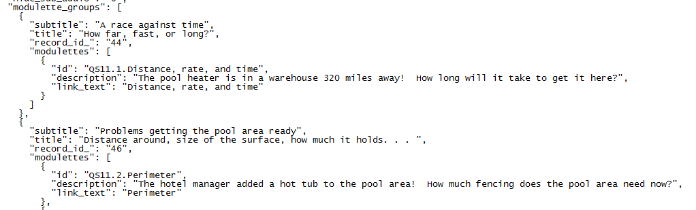

| **json parameter** | **Notes** |
| --- | --- |
| subtitle | This is the bold purple text in the top left corner of the group box. It should describe the skill or skills that the group is covering. |
| title | Optional. This is the purple text underneath the group title. It is usually something to do with the context. |
| record_id | This is the record ID from JUICE’s original content management system. It is for information only and not used in the site. |
| modulettes | This section of **modulette_groups** defines the mini-lessons that should be displayed within the group and includes their link titles and descriptions.   See below for more information. |

# Editing mini-lesson descriptions

Each group on the module page contains one or more mini-lessons or modulettes. The mini-lessons appear within the group in the order in which they are defined in the **module.txt** file.

Each mini-lesson includes a description and a link name. You may update these by editing the parameters in the “modulettes” section of “modulette_groups.”

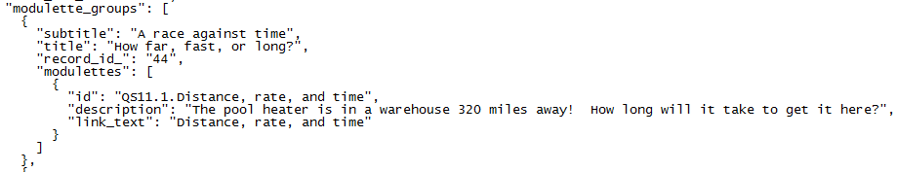

IMPORTANT! Changes made in **module.txt** will only be reflected on that module’s dashboard page. If you are a making a change that should be appear on the JUICE Dashboard or a JUICE mini-lesson page, you must edit **modules.txt** and **modulette.txt** also.

For example, if you change the name of a modulette by editing it in the module.txt file, the new name will appear on the corresponding module page, but will not appear on the JUICE dashboard, or the JUICE mini-lesson (modulette) page unless you also change the **modules.txt** and **modulette.txt** files.

| **json parameter** | **Notes** |
| --- | --- |
| id | This is the modulette’s complete identifier. It has two parts: the modulette ID, which includes the module id, and a brief text description.  The modulette ID portion of this identifier is used by the JUICE application to identify and load the modulette, and is also used in student activity data.  Example: **QS11.1.Distance, rate, and time**  **QS11.1** is the id used to identify this modulette. **QS11** is the module, and **1** is the number of the modulette within the module. **QS11.1** is the first mini-lesson in module QS11.  The number “1” must correspond to the S3 directory name of the modulette within the module directory.  The files for modulette QS11.1 are in S3 directory QS11 / 1  It is recommended as a best practice to not edit the alpha-numeric part of an existing modulette’s ID. You may edit the text part. |
| description | This is the description that appears in the modulette’s box on the module page. JUICE uses this as a “context clue” to help students decide if the modulette covers the skill on which they need help. |
| link_text | This defines the name of the link that appears with the modulette on the modules page.  If you change this value in **module.txt**, and you want it match the mini-lesson title displayed on the dashboard and in the mini-lesson, you must change the modulette title in **modules.txt**, and **modulette.txt,** as well as in the Mongo DB Search tables. See the document *Using tags to improve JUICE Search* for more information about updating Search. |

# Adding and removing modules

## Removing a module

To remove a module from your JUICE program, delete the module’s directory in S3, and edit the **modules.txt** document to remove the module from the JUICE Dashboard as described in the document *Customizing the JUICE Dashboard*. You must also edit the Search tables in Mongo DB so that the module is no longer available as a search result. See the document *Using tags to improve JUICE Search* for more information about updating Search.

## Adding a module

You can add a new module to core JUICE or create one in an alternate program as follows:

1. Create a new module directory in S3. Use the new module’s id as the name of the directory.
2. Copy an existing **module.txt** file into the new directory and edit it to reflect your new module’s content.
3. Add modulettes to the new module.
4. Update **modules.txt** and the Mongo DB Search tables to reflect the new module and modulette content. See the document *Using tags to improve JUICE Search* for more information about updating Search.

CAUTION! Module IDs must be unique to ensure that student activity tracking works properly. They cannot be the same as any of the existing core JUICE module ids or module ids in any of your alternate programs.  
  
To prevent duplicate ids:

1. Review the JUICE module directory names in S3 in both core JUICE and in any program sub directory that is in the /programs directory to make sure you know what ids are already in use.
2. If you are adding more than one module, make a plan for what you are going to cover and then develop a list of module ids for all modules at one time.

To create a new module:

1. Decide what you want the new module’s ID to be. Make sure it is not a duplicate!
2. Go to the appropriate directory in S3—either the core JUICE bucket, or the directory for your alternate program—and click the Create Folder button. Enter the module ID as the folder’s name and save.

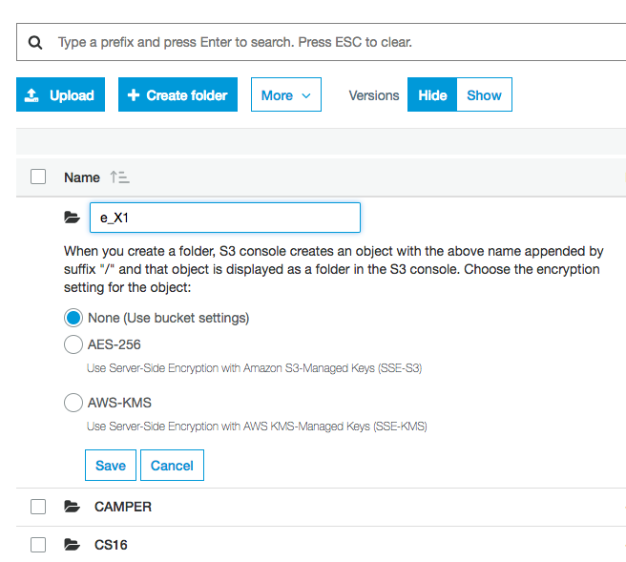

1. The new module directory will be empty. To begin populating it with content, download a **module.txt** file from an existing JUICE module directory and open it with Brackets or other structured editing program.
2. Edit it as desired.
3. Upload the edited **module.txt** file into the new module’s directory.
4. Edit the **modules.txt** file to add your new module to your program’s dashboard and edit the search tables in Mongo DB to make it available to Search. See the document *Using tags to improve JUICE Search* for more information about updating Search.
5. Add modulettes (mini-lessons), images, and the content files that the modulettes will play. See the documentation *Customizing a JUICE mini-lesson* and *Customizing and creating new mini-lesson files* for more information.

# Adding and removing module groups

## Removing a group

To remove a group of mini-lessons from a module page, delete the section that defines the group from the **module.txt** file.

Identify the beginning of the group’s section by finding the group subtitle and title. Delete the open bracket on the line above the subtitle and continue deleting until you reach the open bracket preceding the next group’s section.

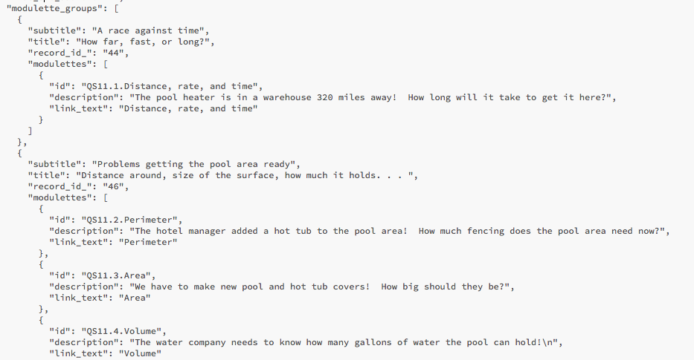

In the image above, the circled section represents a group with one mini-lesson. Deleting the text within the circle will remove the group, but preserve the other groups that come after it.

You must remove the group’s mini-lessons from the program’s **modules.txt** file so that they no longer appear on the JUICE dashboard and also remove them from the Mongo DB Search tables. See the document *Using tags to improve JUICE Search* for more information about updating Search.

## Adding a group

To add a group, copy an existing group section within the **module.tx**t file, and update it as appropriate for the new group’s information and mini-lessons.   
  
You must also edit the program’s **modules.txt** file to add the new mini-lessons to the JUICE dashboard and update the Mongo DB Search tables to include them if desired. See the document *Using tags to improve JUICE Search* for more information about updating Search.

# Adding and removing mini-lessons

## Removing a mini-lesson

To remove a mini-lesson from a group, delete the three lines containing the “id”, “description”, and “link_text” fields, as well as the brackets enclosing the three lines.



In the image above, the circled section represents one mini-lesson or modulette. Deleting the lines within the circle will remove the modulette, but preserve the other modulettes in the group.

You must remove the mini-lesson from the program’s **modules.txt** file so that it no longer appears on the JUICE dashboard and also remove it from the Mongo DB Search tables. See the document *Using tags to improve JUICE Search* for more information about updating Search.

## Adding a mini-lesson

If you would like to add a mini-lesson to a module, do the following:

1. Copy existing mini-lesson information in the **module.txt** file into the section for one of the existing groups and modify it to update the id and title. Or, add a section for a new modulette group first, then copy mini-lesson information into it and modify.
2. Update the file **modules.txt** with the mini-lesson title so that it will appear on the JUICE dashboard and update the Mongo DB Search tables to include it if desired. See the document *Using tags to improve JUICE Search* for more information about updating Search.
3. Create a new S3 directory within the module directory by copying an existing modulette directory, and change the name to match your mini-lesson’s id. For example, if you have added a mini-lesson called **QS1.7.Adding fractions**, create a directory within the QS1 directory called **7**
4. Edit the **modulette.txt** and **content** files within the new directory as appropriate for your new mini-lesson as described in the documentation *Customizing a modulette.*